## UNDERSTANDING DIFFERENT LEARNING

## METHODS BY VISUALISTION USING MATLAB

## AND PYTHON LANGUARGE.

BY-BISHAL SAHA

REG NO-20BEE0298

Implemented using Matlab and Python:-

1.Hebbian learning

2.Perspectron learning

3.Adaline

4.Auto-Associative

5.XOR-Problems

## OBJECTIVES:-

The objective of our project is to visualize some of the learning laws and algorithms that we have studied in class lecture,by taking the help of softwares like Matlab and python.The other objective of our project is to reduce the man power and enables a normal human being to easily predict, recognize, weight update, visualize ,calculate, recognize,classify the neural network using such Matlab and Pythons softwares.

# Introduction:-

We all know that artificial neural network plays a very significant role in our daily life,and with the help of different learning methods and algorithms we can make predictions,can do image recognization,voice recognization,data synchronization,classification,in robotics,artificial intelligence and a lot.In such scenario we employ some of the most powerful deep learning tools which makes our job very easy,attractive and innovative with full of vizualiztaion i.e Matlab,Python,Java etc.

## Hebb Learning.{MATLAB CODE}

**Hebb** proposed a mechanism to update weights between neurons in a **neural network**. This method of weight updation enabled neurons to learn and was named as **Hebbian Learning**

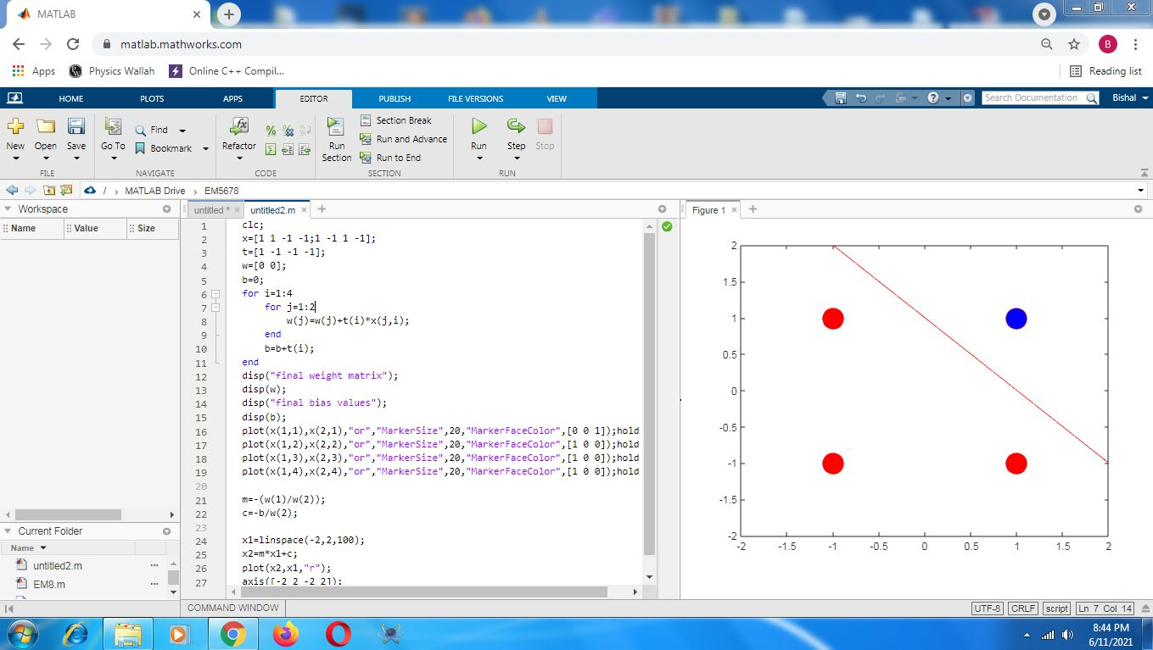

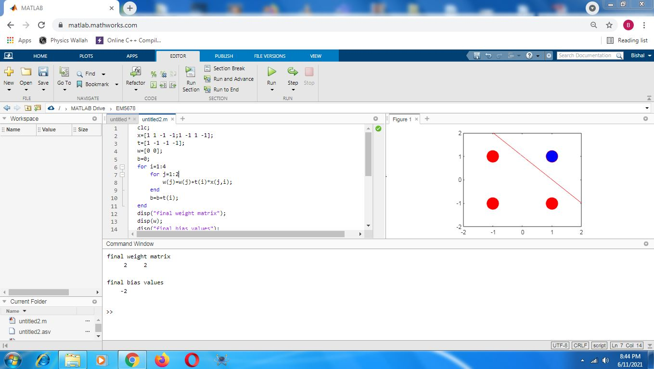

# Perceptron Learning.{MATLAB CODE}

A **Perceptron** is an **algorithm** for supervised **learning** of binary classifiers. This **algorithm** enables neurons to **learn** and processes elements in the training set one at a time. There are two types of **Perceptrons**: Single layer and Multilayer.

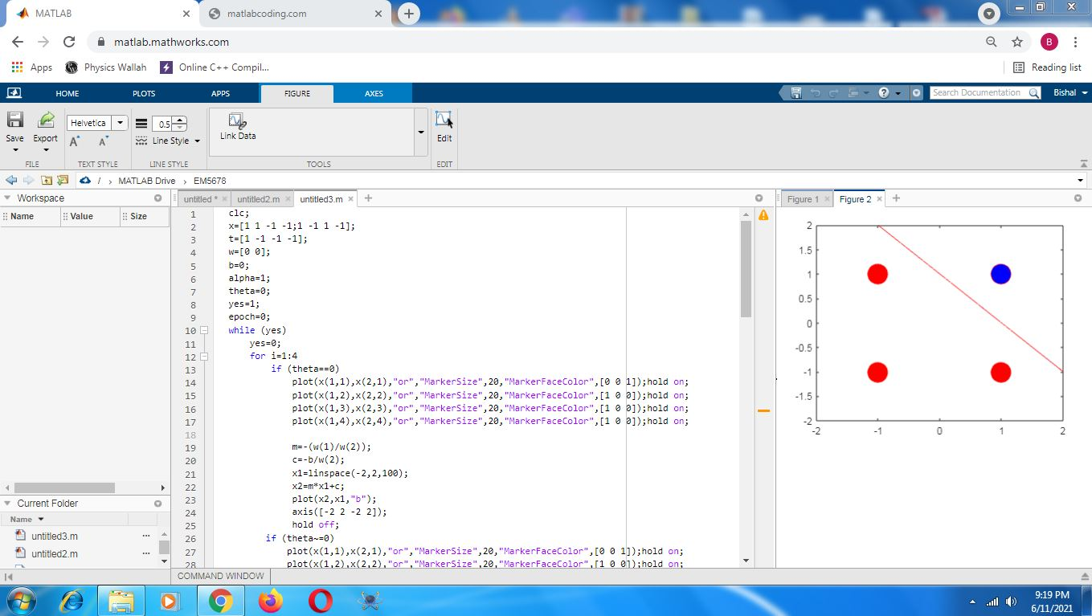

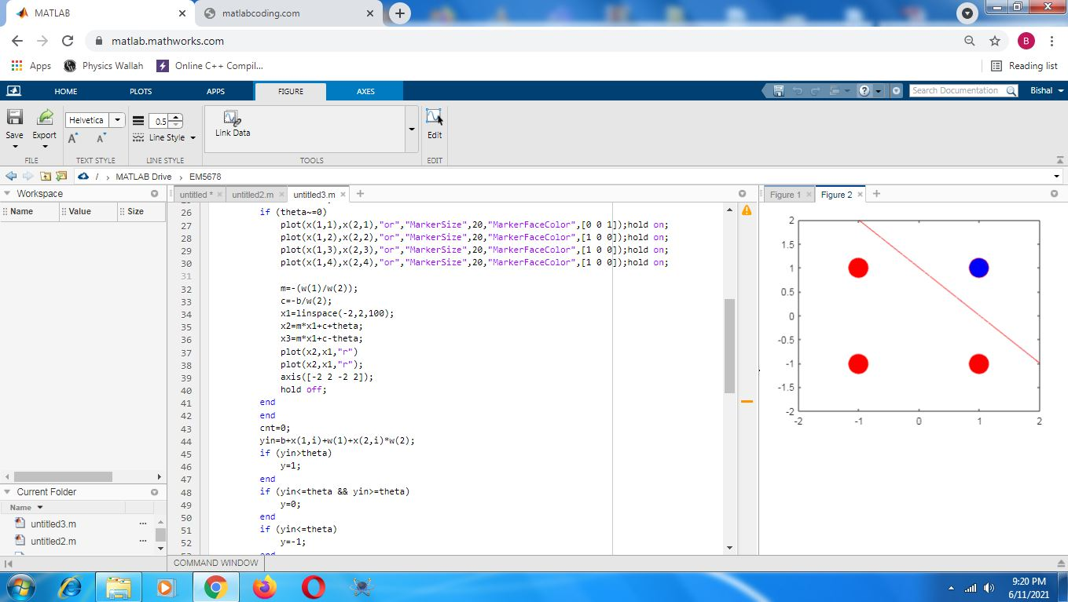

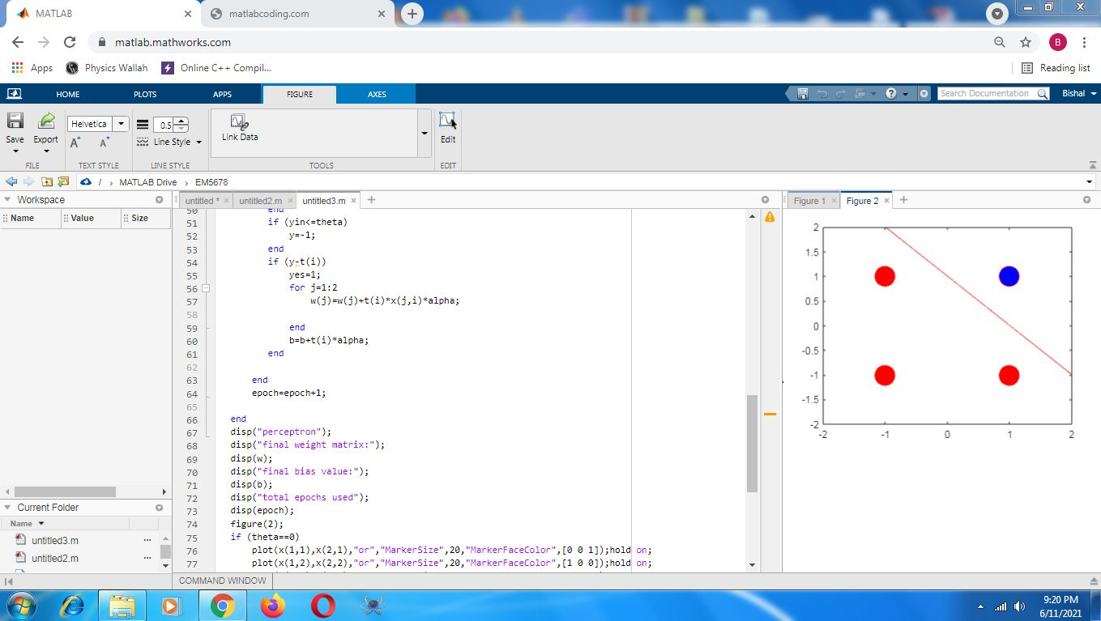

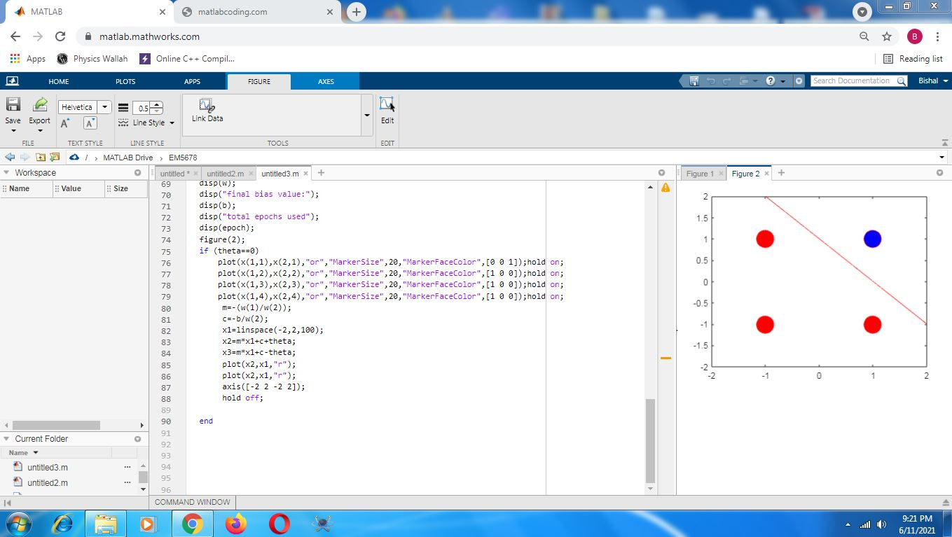

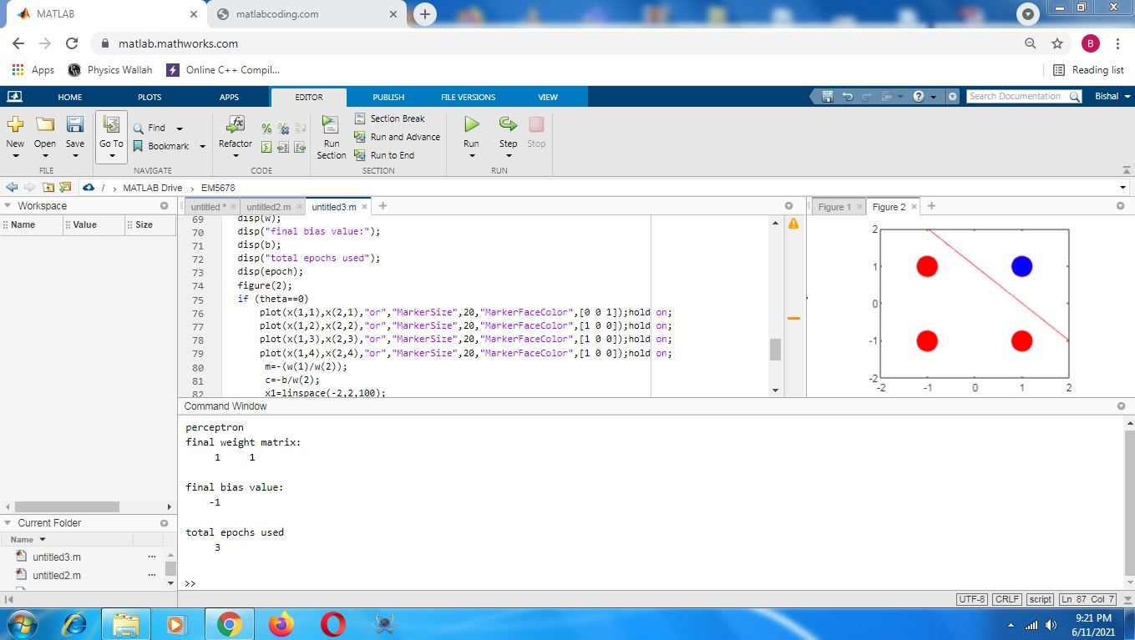

Adaline .{MATLAB CODE}

**ADALINE** (Adaptive Linear **Neuron** or later Adaptive Linear Element) is an early single-layer artificial **neural network** and the name of the physical device that implemented this **network**. The **network** uses memistors. ... It is based on the McCulloch–Pitts **neuron**. It consists of a weight, a bias and a summation function.

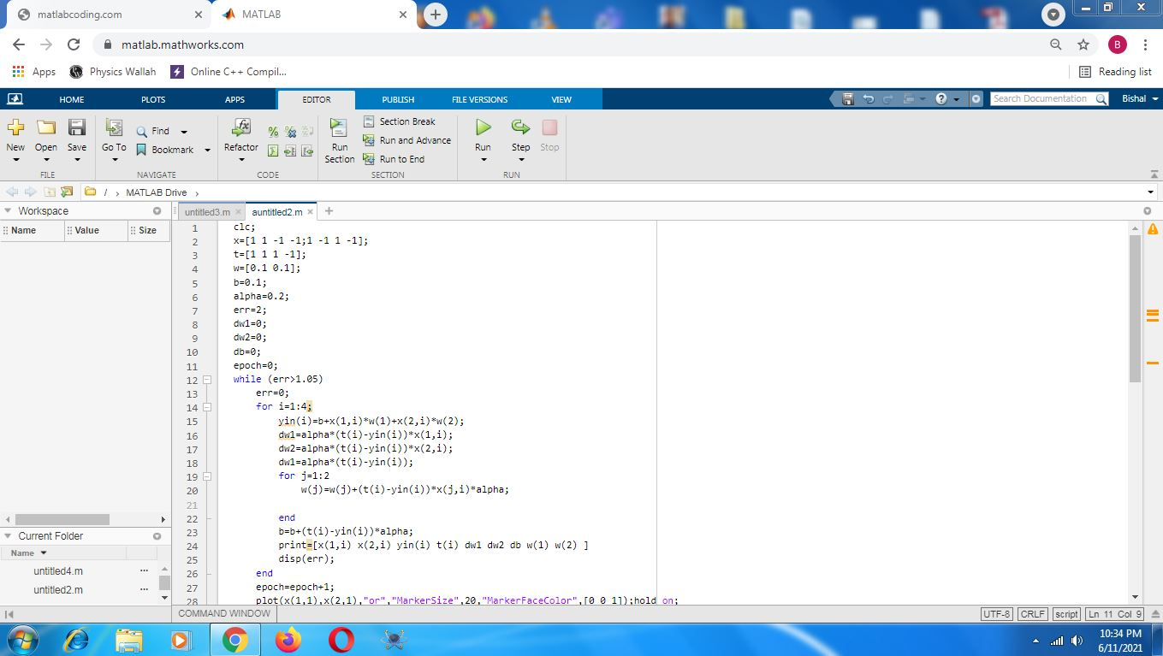



# Auto-Associative .{MATLAB CODE}

**Autoassociative neural networks** are feedforward **nets** trained to produce an approximation of the identity mapping between **network** inputs and outputs using backpropagation or similar learning procedures. The key feature of an **autoassociative network** is a dimensional bottleneck between input and output.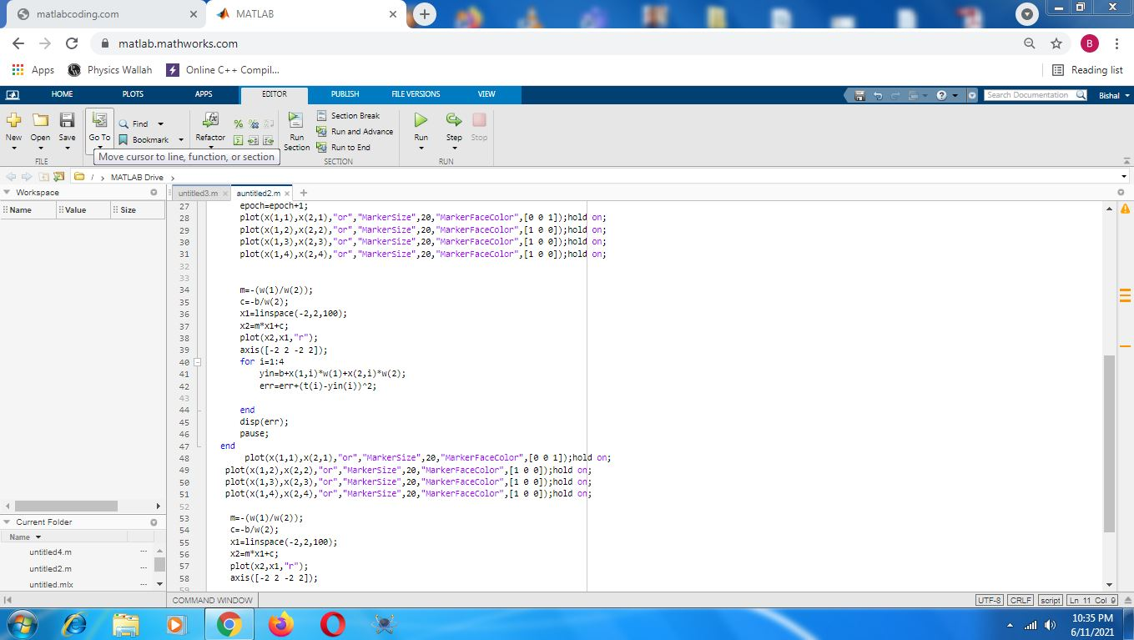

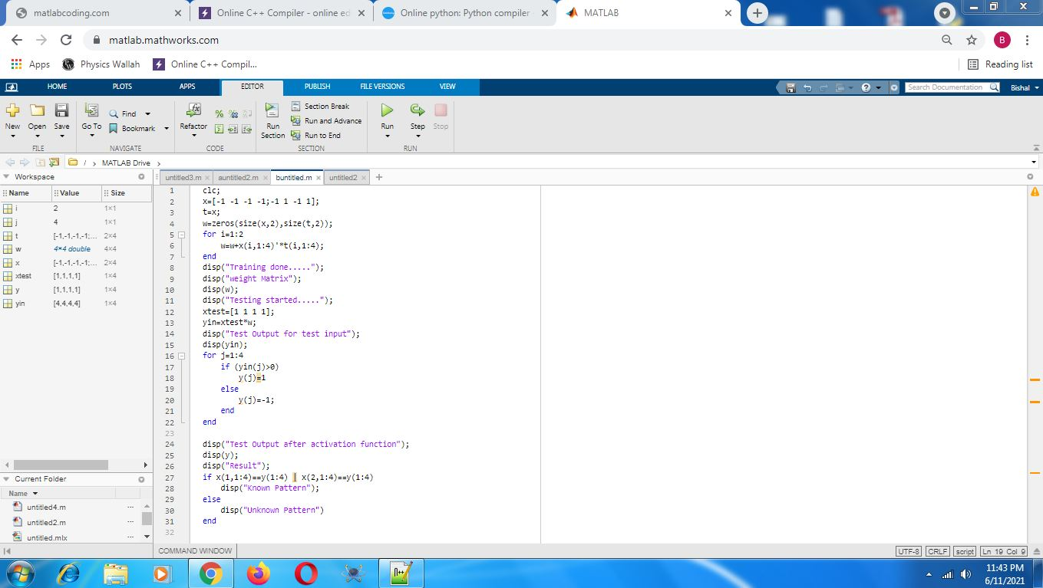

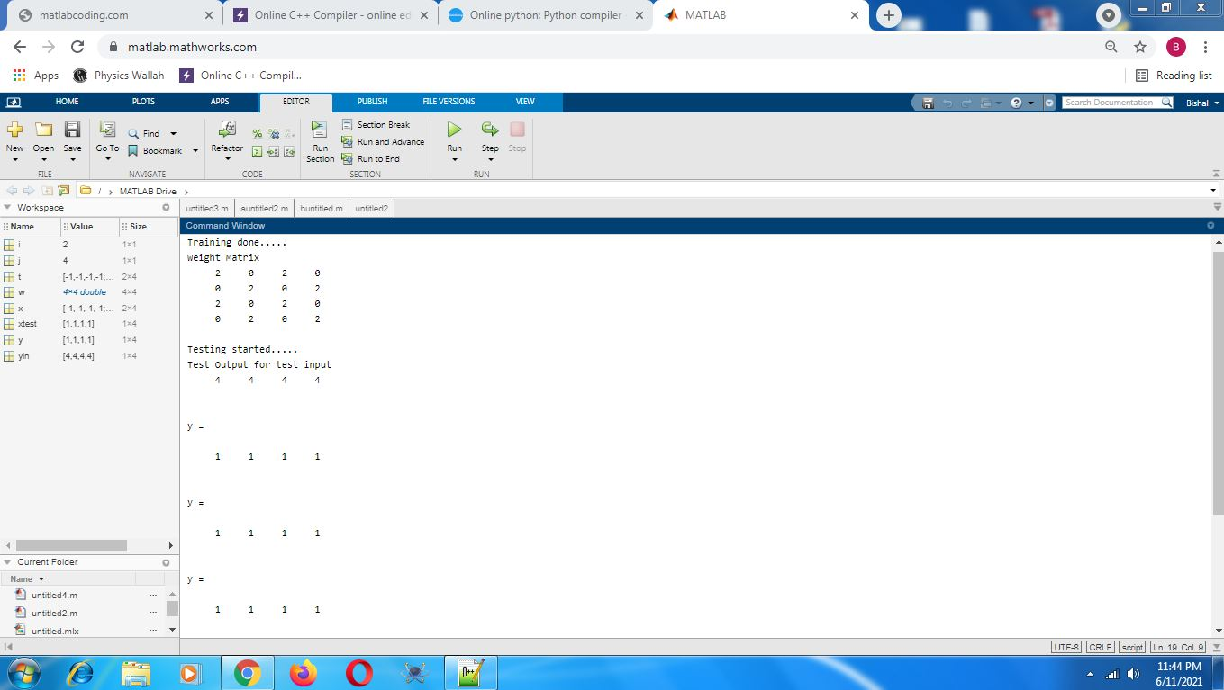

XOR Problems:- The **XOR**, or “exclusive or”, **problem** is a classic **problem** in ANN research. It is the **problem** of using a **neural network** to predict the outputs of **XOR** logic gates given two binary inputs. An **XOR** function should return a true value if the two inputs are not equal and a false value if they are equal.

{PYTHON CODE}

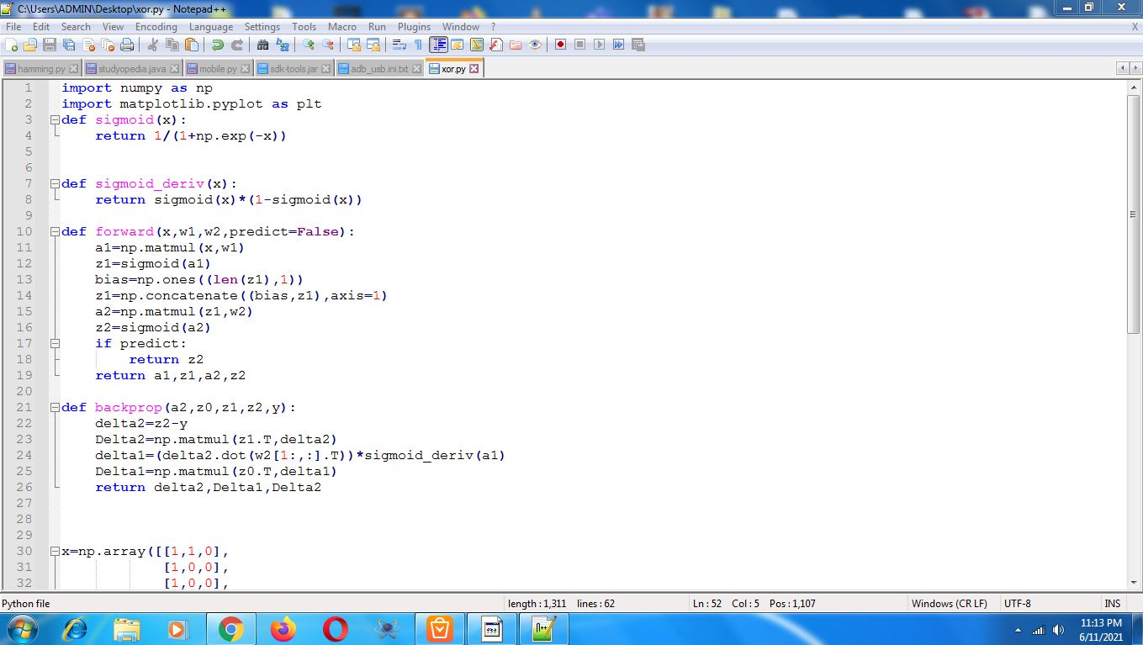

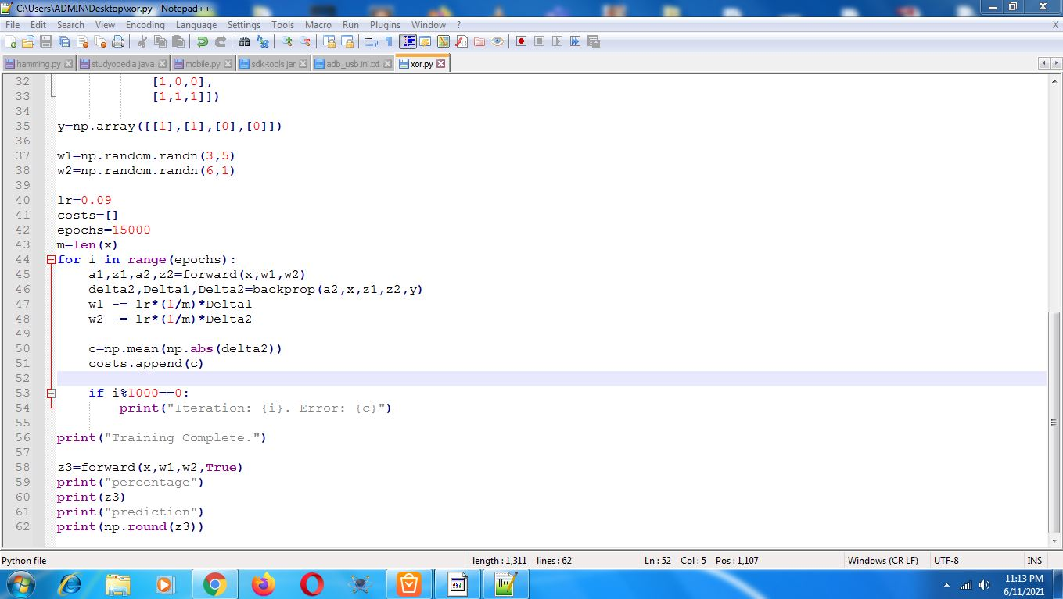

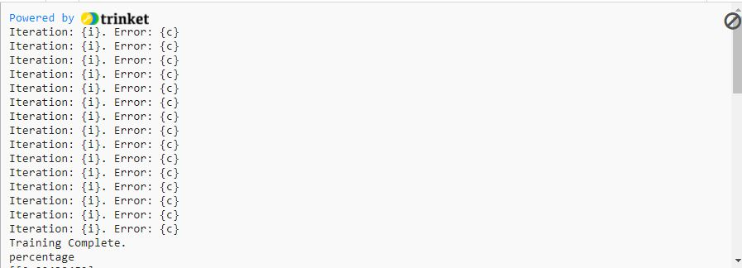

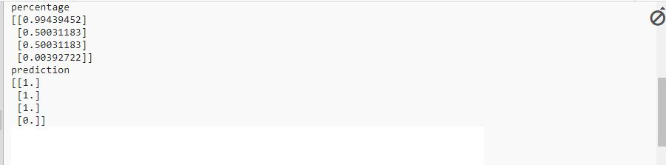

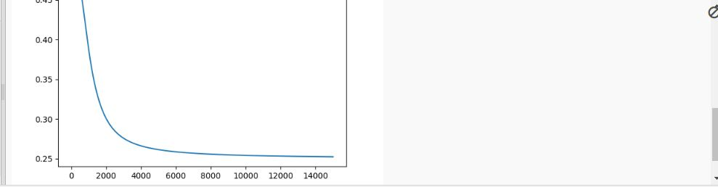

**RESULTS AND CONCLUSION**

* The tools like Matlab and Python helps a lot to all domains of people who directly or indirectly connect with neural network because they can simulate,visualize,asily achieve long algorithms etc in neural networks,atlast this tools works like a connecting bridge between beginners and developers.
* ***Matlab*** and ***Deep Learning*** Toolbox provide command-line function and apps for creating,***training***,simulating and ***Prediction*** of neural network.
* The apps make it easy to develop neural networks for tasks such as ***classification,***regresion and clustering.Vectors,Layers and linear regression are some of the building blocks of Neural Network.The data is stored as vectors and with ***Python*** you store these vectors in arrays.